Bahria University,

Karachi Campus

LAB EXPERIMENT NO.

08

LIST OF TASKS

|  |  |
| --- | --- |
| TASK NO | OBJECTIVE |
| **01** | Implement KNN for Iris Flower Classification in KNIME. |
| **02** | Implement Using Python KNN for Iris Flower Classification. |
| 03 | Implement a Movie Recommendation System Using K-Nearest Neighbors (KNN) in KNIME. |

Submitted On:

25-04-2024

(Date: DD/MM/YYYY)

**Task No. 01:** Implement KNN for Iris Flower Classification in KNIME.

**Description**: You are tasked with implementing the K-Nearest Neighbors (KNN) algorithm using KNIME Analytics Platform to classify Iris flowers based on their features. The Iris dataset contains four features: sepal length, sepal width, petal length, and petal width. There are three classes of Iris flowers in the dataset: Setosa, Versicolor, and Virginica.

**Solution:**

**Output:**

**Task No. 02:** Implement KNN for Iris Flower Classification.

**Description**: You are tasked with implementing the K-Nearest Neighbors (KNN) algorithm to classify Iris flowers based on their features. The Iris dataset contains four features: sepal length, sepal width, petal length, and petal width. There are three classes of Iris flowers in the dataset: Setosa, Versicolor, and Virginica.

**Solution:**

from sklearn.datasets import load_iris

from sklearn.model_selection import train_test_split

from sklearn.neighbors import KNeighborsClassifier

from sklearn.metrics import accuracy_score

iris = load_iris()

X = iris.data # Features

y = iris.target # Target labels

X_train, X_test, y_train, y_test = train_test_split(X, y, test_size=0.2, random_state=4)

k = 3

knn_classifier_euclidean = KNeighborsClassifier(n_neighbors=k, metric='euclidean')

knn_classifier_euclidean.fit(X_train, y_train)

y_pred_euclidean = knn_classifier_euclidean.predict(X_test)

accuracy_euclidean = accuracy_score(y_test, y_pred_euclidean)

print("Accuracy with Euclidean distance metric:", accuracy_euclidean)

knn_classifier_minkowski = KNeighborsClassifier(n_neighbors=k, metric='minkowski')

plt.show()

print("Accuracy with Minkowski distance metric:", accuracy_minkowski)

cm_minkowski = confusion_matrix(y_test, y_pred_minkowski)

plt.figure(figsize=(8, 6))

sns.heatmap(cm_minkowski, annot=True, fmt="d", cmap="Greens")

plt.title("Confusion Matrix - Minkowski Distance Metric")

plt.xlabel("Predicted Labels")

plt.ylabel("True Labels")

plt.show()

**Output:**

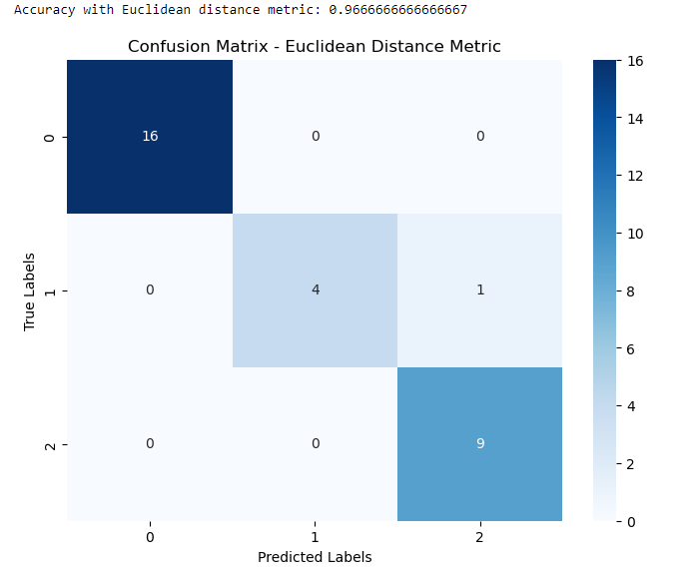

**Task No. 03:** Implement a Movie Recommendation System Using K-Nearest Neighbors (KNN) in KNIME.

**Description**: You are tasked with building a movie recommendation system using the K-Nearest Neighbors (KNN) algorithm in KNIME Analytics Platform. The goal of the recommendation system is to suggest movies to users based on their similarity to other users'

preferences.

**Solution:**

import numpy as np # linear algebra

import pandas as pd # data processing, CSV file I/O (e.g. pd.read_csv)

import matplotlib.pyplot as plt

import seaborn as sns

movie = pd.read_csv("movies.csv")

movie

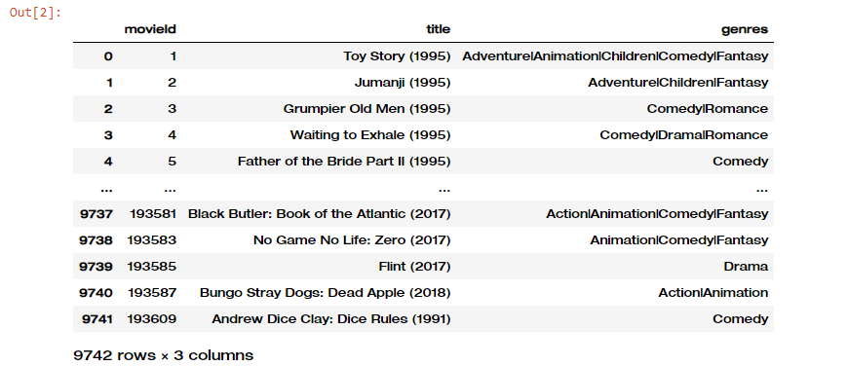

rating = pd.read_csv("ratings.csv")

rating

tags = pd.read_csv("tags.csv")

tags

links = pd.read_csv("links.csv")

links

data = pd.merge(movie,rating)

data

data.drop(["genres","timestamp"], axis = 1,inplace = True)

data

data_pivot = data.pivot_table(index='userId',columns='title',values='rating')

data_pivot

data_pivot2 = pd.pivot(index = "movieId", columns = "userId", data = rating, values = "rating")

data_pivot2

Movie_voted = pd.DataFrame(rating.groupby("movieId")["rating"].agg("count"))

Movie_voted.reset_index(level = 0, inplace = True)

Movie_voted

User_Voted = pd.DataFrame(rating.groupby("userId")["rating"].agg("count"))

User_Voted.reset_index(level = 0, inplace = True)

User_Voted

data_pivot2.fillna(0, inplace = True)

data_pivot2

dataLast = data_pivot2.loc[Movie_voted[Movie_voted["rating"] > 10]["movieId"],:]

dataLast = dataLast.loc[:, User_Voted[User_Voted["rating"] > 60]["userId"]]

dataLast

**Recommendation Systems**

from scipy.sparse import csr_matrix

csr_data = csr_matrix(dataLast.values)

dataLast.reset_index(inplace=True)

csr_data

from sklearn.neighbors import NearestNeighbors

knn = NearestNeighbors(metric='cosine', algorithm='brute', n_neighbors=20, n_jobs=-1)

knn.fit(csr_data)

def movie_recommendation(movie_name):

for val in rec_movie_indices:

movie_idx = dataLast.iloc[val[0]]['movieId']

idx = movie[movie['movieId'] == movie_idx].index

recommend_frame.append({'Title':movie.iloc[idx]['title'].values[0],'Distance':val[1]})

df = pd.DataFrame(recommend_frame,index=range(1,n_movies_to_reccomend+1))

return df

else:

return "No movies found. Please check your input"

# result of Recommendation System # result of Recommendation System

movie_recommendation('Iron Man')

movie_recommendation('Fight Club')

